#### Preliminaries.

# TITLE: NYERI EVENT PLANNING SYSTEM.

**Presenters:**

|  |  |
| --- | --- |
| BRIDGET NGUGI | CO26-01-0985/2021 |
| MOSES ETYANG’A | C026-01-1063 /2021 |
| TONNY GITONGA | C026-01-1032/2021 |

**SUBMISSION TO:** DEDAN KIMATHI UNIVERSITY BOARD.

**TIME:** FEBRUARY SERIES.

# Declaration.

We declare our project to be ours and not plagiarized from any site or developed by other people apart from us. Apart from the necessary assistance from our lecturers, we have done a lot of research and developed the system fully by ourselves.

# Acknowledgement.

We would like to thank our university, Dedan Kimathi, for introducing attachment to the curriculum giving us opportunity to work on projects and providing the resources to complete the projects. We also acknowledge our lecturers, GAs, parents, siblings and our classmates for they aided and encouraged us throughout the project. We thank them very much for they have contributed to the full functionality and completion of our project.

# Dedication.

We dedicate this project to our almighty God because his grace has aided us throughout the project.

# Abstract.

Our system will allow users find details of available venues to host their events as well as the capacity of each venue. It will also provide a filtering property that will aid clients to meet their preferences when searching for a suitable venue. This system will take event planning to a whole new level due to the features it will provide to its users.

# Table of Contents.

TITLE: NYERI EVENT PLANNING SYSTEM. 1

Declaration. 2

Acknowledgement. 3

Dedication. 4

Abstract. 5

Table of Contents. 6

List of Figures. 8

Chapter 1. 9

1.1 Background study. 9

1.2 Problem Statement. 9

1.3 Objectives. 9

1.3.1 General. 9

1.3.2 Specific. 9

1.4 Research Question. 10

1.5 Justification. 10

1.6 Scope. 10

1.7 Summary. 11

Chapter 2. 12

2.1 Introduction to Literature review. 12

2.2 Benefits of literature review. 12

2.3 Global perspective. 13

2.3.1 Whova. 13

2.3.2 Allseated. 15

2.4 Regional Case Study. 16

2.4.1 Eventbrite 17

2.4.2 Lagos International Trade Fair. 18

2.5 Local Case Study. 20

2.5.1 TicketSasa. 20

2.5.2 Mookh. 22

2.6 Strength, Weakness, Opportunity and Threats (SWOT). 24

2.7 Research Gap. 24

Chapter 3. 25

3.1 Introduction to Methodology. 25

3.2 System Methods 25

Phases of iterative model 25

Benefits 26

Disadvantages 26

3.3 Research Design Techniques. 26

3.4 Location of Study (Nyeri). 27

3.5 Population of study. 27

3.6 Sampling and Sampling Procedure. 27

3.7 Data Collection Tools. 28

3.8 Data Representation and Analysis. 28

3.9 Test of the Data Collection Tools Reliability. 28

3.10 Research Ethics. 29

3.11 Conclusion. 29

Chapter 4. 30

4.1 Requirements. 30

4.1.1 Functional Requirements. 30

4.1.2 Non-Functional Requirements. 30

4.2 Data Analysis. 31

4.3 System Analysis. 33

4.3.1 UML Diagrams: 33

4.3.2 DFD: 33

4.3.3 Activity Diagram: 34

4.4 System Design. 35

4.4.1 Flow Charts: 35

4.4.2 UI Design: 38

4.5 Database Design. 39

Chapter5 41

Test and results 41

5.1.Introduction 41

5.2.Test cases 42

5.3.Sample results 44

Chapter 6 50

Implementation and development 50

6.1.Introduction 50

6.2.Data conversion 50

6.3.Implementation strategy 51

6.4.System specification 53

6.5.Support and training 55

Chapter7 57

Conclusion and recommendation 57

7.1Conclusion. 57

Appendices. 57

# List of Figures.

Figure 1 - Count of EVENT NAME by TYPE 31

Figure 2 - Attendance 32

Figure 3 - Sum of ATTENDANCE by TYPE 32

Figure 4 - Descending Distribution of Attendance 33

Figure 5 - Use Case Diagram 34

Figure 6 - DFD 34

Figure 7 - Activity Diagram 35

Figure 8 - Admin Flowchart 37

Figure 9 - Users Flowchart 39

Figure 10 - Homepage UI 39

Figure 11 - Checkout Table Database Design 40

Figure 12 - Event Venues available 46

# Chapter 1.

**Event Planning System.**

## 1.1 Background study.

This project is tied to the business field that deals with event planning. It will solve a lot of challenges brought about by manually managing such systems e.g., data redundancy, lost data, miswritten data and low ease of access of data.

## 1.2 Problem Statement.

Event planning can be a complex and time-consuming process which if approached manually, can be very inefficient and error-prone. An event planning system can help streamline the process but most are expensive and complex to use. There is a need for a cost-effective and user-friendly system that simplifies the process further and puts the focus on delivering quality event locations.

## 1.3 Objectives.

### 1.3.1 General.

The system’s main objective is to provide a digital platform where customers can view and book available event venue options in an efficient manner; without any physical hassle.

### 1.3.2 Specific.

* Enable customers to view and book available event venues.
* Enable customers to view their profile and venue bookings.
* Enable the admin to view a list of customers.
* Enable the admin to view the feedback submitted by the customers.
* Enable the admin to create and view event venue listings.

## 1.4 Research Question.

Our organization started about a decade ago when our Founder/CEO saw a market opportunity in the event planning field. It is composed of less than 50 employees who fall into the following categories:

* 1. CEO – overall manager of the organization.
  2. Operations Manager – oversees the day-to-day operations and co-ordinates with event planners and other employees.
  3. Event Planning – responsible for planning and coordinating events.
  4. Marketing – responsible for promoting events and communicating with attendees and sponsors.
  5. Technical Support – responsible for maintaining and troubleshooting the management system.

## 1.5 Justification.

This system will solve the following issues experienced in the event planning field:

1. Manually processing of data – this brings about a lot challenges in managing data as they are done so in paper form. A lot of data is lost and it can be very hard to locate specific information especially if time factor is considered.
2. Difficulty in reaching the market – advertising of an event booking company can be quite challenging and expensive; they will have to use a lot of money to print out advertising papers or media advertising like radio or tv.

## 1.6 Scope.

The event planning system is limited to Nyeri as we provide event planning solutions for locations specifically around Nyeri. Our planning system can allow adding of events and their booking. The customers can view the available venue locations and book them so as to host an event.

## 1.7 Summary.

The event planning system brings digitization of event planning making it more efficient and beneficial to an organization. It also eases reach and communication between customers and the organization.

# Chapter 2.

## 2.1 Introduction to Literature review.

It is an overview of previously published works on a specific topic. It provides an overview of current knowledge allowing one to identify relevant theories, methods and gaps used in existing research that can later be applied to one’s research paper.

**Event planning** is the process of planning and coordinating events for a target audience. Event planning system involves the application of management in the creation and development of large-scale events to its clients. It provides a platform that easily connects venue owners with the ready market thus boosting revenue.

## 2.2 Benefits of literature review.

* Enables researchers to gain better understanding of the existing topic of study
* Allows effective communication among researchers by helping them decide which issues are significant.
* Provides context of research to researchers.
* Enables researchers to formulate clear and concise research questions
* Enables researchers to compare and contrast existing research on a particular topic to draw better conclusions from it.
* It enables researchers to identify problems, issues or controversies in the existing body of knowledge on their topic.
* It saves time for the researchers by identifying relevant studies and avoid unnecessary duplication of effort by focusing on the most important issues.

**Case studies.**

It refers to a detailed examination of a similar system that has already been developed and implemented in a different geographic area or industry as the system being developed.

The purpose of a case study is to gain insight into how the similar system works, how it was developed, and how it has been received by its users.

## 2.3 Global perspective.

Here we analyze projects in existence outside Africa continent so as to analyze the approach used in developing the system which is similar to our proposed system.

The following are the global case studies we researched:

### 2.3.1 Whova.



Whova is a mobile event management app that is designed to assist event attendees navigate through their events with mobile brochures.

It’s an all-in-one event management system founded in 2012 by Yuannyuan Zhou, Soyeon Park among others.

Its headquarters is in San Diego CA, USA.

**Features.**

* Online registration-customers are able to register for an event online reducing costs for printing invitation cards.
* Event promotions-.
* Speaker and schedule management.
* Check-ins.
* Polling-polls are conducted to check attendance.
* Virtual conference-meetings can be done virtually without necessitating a physical meeting.

**Advantages.**

* This platform allows one to manage in-person or virtual events.
* Provides event management tools and event marketing solutions.
* Facilitates networking among event attendees.
* It customizes client’s agenda with its website builder
* One can update and synch details across webpages and social media with a single edit
* Reduced printing costs by replacing printed programs with a customized and responsive mobile app
* Its mobile friendly and offers affordable services.

**Disadvantages.**

* The cost of using Whova for small meetings is high.
* There are little connectivity issues
* It’s not easy to access the list of participants and their contact information
* It’s difficult to download the pictures and literature that have been uploaded.

**Citation.**

This system was developed by: Yuanyuan Zhou, Soyeon Park, Tianwei Sheng and Weiwei Xong in 2012.

### 2.3.2 Allseated.

It’s a cloud-based collaboration of networks in the events industry. Was developed in Atlanta Georgia in USA by Daniel Anisman and Sandy Hammer in 2011.

It connects venues, vendors, planners and event hosts thus transforming event industry with collaborative digital planning tools and enhanced visualizations to design floorplans, arrange settings and more

**Features.**

* Mobile check-in -guests are easily managed in the entrance as they check in through their mobile phones
* 3D floor plans-planning for an event can be done virtually through 3D floor plans minimizing physical workload of rearranging items
* Table and buffet builders
* Side-by-side timelines
* Guest list managements-list of guests are easily managed from the system

**Advantages.**

* Virtual reality and 360-degree diagramming reduce operating costs
* This gives the planners ability to present their visions to their clients through virtual walkthroughs
* Eliminates the need to spend their valuable time in creating physical samples that may not appeal to the clients.
* Floor plan templates enables planners to make changes without starting from the beginning
* Venues, vendors and planners can all collaborate on a single website

**Disadvantages.**

* Does not allow sharing and editing of floor plans among colleagues in the software
* It times out quickly such that when user idles for a long duration the session is timed out and has to re-login.
* The inventory of the products is too small.

**Citation.**

The Allseated EventSystem was actually developed by:Daniel Anisman & Sandy Hammer in (2011).

## 2.4 Regional Case Study.

In Africa, Eventbrite is a leading event management platform that provides end-to-end event planning services. It was founded in 2006 by Kevin Hartz, Julia Hartz, and Renaud Visage in San Francisco, California, United States. The platform has a strong presence in Africa and is widely used by event organizers to create and manage events.

### 2.4.1 Eventbrite

**Features**

* Online registration: Eventbrite allows attendees to register for events online, saving time and money.
* Ticketing: The platform enables organizers to create and sell tickets for events.
* Event promotion: Eventbrite provides tools for event promotion, such as email marketing and social media integration, to reach a larger audience.
* Attendee management: The platform makes it easy to manage attendees, such as tracking attendance and sending reminders to those who have registered.
* Payment processing: Eventbrite provides a payment processing system that accepts multiple payment options, including credit/debit cards and PayPal.
* Data tracking: Eventbrite offers tools to track event performance, such as ticket sales and attendee demographics, to help organizers understand their audience and improve future events.

**Advantages**

* Strong presence in Africa: Eventbrite has a large user base in Africa, making it a reliable platform for event management.
* Ease of use: The platform is user-friendly and easy to navigate, even for those who are new to event planning.
* Cost-effective: Eventbrite offers affordable pricing plans for event organizers, with a fee structure that is transparent and easy to understand.
* Marketing tools: Eventbrite provides built-in marketing tools that help organizers to promote their events and reach a wider audience.
* Data analytics: The platform provides valuable insights and analytics on attendee demographics and event performance, helping organizers to make data-driven decisions.

**Disadvantages**

* Limited customization: While Eventbrite provides templates for event pages, organizers have limited control over the design and branding of their event pages.
* Payment processing fees: Eventbrite charges a fee for payment processing, which can add up for large events with high ticket sales.
* Competition: Eventbrite faces competition from other event management platforms, which can make it harder for organizers to stand out in a crowded market.

**Citation**

Eventbrite was founded by: Kevin Hartz, Julia Hartz, and Renaud Visage in San Francisco, California, United States in 2006.

### 2.4.2 Lagos International Trade Fair.

The Lagos International Trade Fair is an annual event held in Lagos, Nigeria, which showcases the country's industrial, commercial, and agricultural potential. It was first held in 1977 and has since become one of the largest trade fairs in Africa. The event attracts both local and international exhibitors and visitors, offering a platform for businesses to showcase their products and services.

**Features**

* Exhibitions: The trade fair features exhibitions of various products and services from a wide range of industries, including agriculture, manufacturing, and technology.
* Business-to-business (B2B) meetings: The event provides a platform for businesses to hold B2B meetings and establish business partnerships and collaborations.
* Seminars and conferences: The trade fair includes seminars and conferences that address industry-specific topics, providing attendees with valuable insights and knowledge.
* Networking: The event offers opportunities for attendees to network with industry experts, government officials, and other business leaders.
* Entertainment: The trade fair includes cultural performances, food stalls, and other entertainment activities, providing a festive atmosphere for attendees.

**Advantages**

* Business opportunities: The trade fair provides businesses with an opportunity to showcase their products and services to a wide audience, helping to generate new leads and customers.
* Networking: The event offers opportunities for businesses to establish new connections and collaborations, leading to new business opportunities.
* Learning and development: The seminars and conferences provide attendees with valuable insights and knowledge that can help them improve their businesses.
* Brand exposure: Exhibitors can increase their brand exposure by participating in the trade fair, potentially leading to increased sales and growth.
* Cultural experience: The event showcases Nigeria's diverse culture and offers attendees a chance to experience local food, music, and other cultural activities.

**Disadvantages**

* Cost: Participation in the trade fair can be expensive for some businesses, particularly smaller ones, as it involves costs for exhibition space, logistics, and other expenses.
* Competition: With the large number of exhibitors, it can be challenging for businesses to stand out and attract attention from attendees.
* Limited duration: The trade fair only lasts for a limited period, and businesses may not have enough time to make the necessary connections and generate leads.

**Citation**

The Lagos International Trade Fair has been held annually since 1977 in Lagos, Nigeria.

## 2.5 Local Case Study.

By conducting a local case study, the development team can learn from the experiences of others who have already developed and implemented a similar system. This can help to identify potential challenges and solutions, as well as best practices for development and implementation. Below are the local case studies that we researched:

### 2.5.1 TicketSasa.

TicketSasa is an online ticketing platform that allows event organizers to sell tickets and manage their events. The platform was launched in Kenya in 2010.

**Features.**

* Multiple Payment Options: TicketSasa allows attendees to pay for tickets using mobile money, credit/debit cards, or vouchers. This flexibility makes it easy for attendees to purchase tickets and for organizers to receive payments.
* Social media integration: The platform integrates with social media platforms like Facebook and Twitter, making it easy for organizers to promote their events and for attendees to share information about them.
* Detailed analytics and reporting: TicketSasa provides organizers with detailed analytics and reporting features that allow them to track ticket sales, revenue, and attendance. This information can be used to make informed decisions about event planning and marketing.
* Mobile app: TicketSasa offers a mobile app that allows organizers to manage their events on the go. The app provides access to real-time sales data and event information, making it easy to stay on top of everything.

**Advantages**

* Multiple payment options make it easy for attendees to purchase tickets and for organizers to receive payments.
* Social media integration makes it easy for organizers to promote their events and for attendees to share information about them.
* Detailed analytics and reporting features provide organizers with valuable insights for event planning and marketing.
* Mobile app allows organizers to manage events on the go.

**Disadvantages**

* TicketSasa charges a service fee for each ticket sold, which can increase the cost for event organizers and attendees.
* The platform may not be as well-known as some of its competitors, which could impact its reach and visibility.
* Some users have reported issues with the ticket scanning process at events, which can cause delays and frustration for attendees.

**Citation.**

This system was developed by:

Craft Silicon, a Kenyan software development company that was founded in 1999.

### 2.5.2 Mookh.

Mookh is an event ticketing platform that was founded in Kenya in 2015. It provides event organizers with a range of features to help them sell tickets and manage their events.

**Features.**

* Customizable ticket sales pages: Mookh allows organizers to create custom ticket sales pages that reflect their brand and event. This can help increase ticket sales and make the event more memorable for attendees.
* Integration with social media: Mookh integrates with social media platforms like Facebook and Twitter, making it easy for organizers to promote their events and for attendees to share information about them.
* Real-time ticket sales data and reporting: Mookh provides organizers with real-time sales data and reporting features that allow them to track ticket sales, revenue, and attendance. This information can be used to make informed decisions about event planning and marketing.
* Automated email and SMS notifications: Mookh sends automated email and SMS notifications to attendees, reminding them about the event and providing them with important information like venue details and ticket information.

**Advantages**

* Customizable ticket sales pages allow organizers to create a unique and branded experience for attendees.
* Social media integration makes it easy for organizers to promote their events and for attendees to share information about them.
* Real-time sales data and reporting features provide organizers with valuable insights for event planning and marketing.
* Automated email and SMS notifications help to keep attendees informed and engaged.

**Disadvantages:**

* Mookh charges a service fee for each ticket sold, which can increase the cost for event organizers and attendees
* The platform may not be as well-known as some of its competitors, which could impact its reach and visibility
* Some users have reported issues with the platform's customer support, which can cause frustration and delays in resolving issues

**Citation.**

Mookh was developed by:The Kenyan startup Mookh Africa Limited, which was founded in 2016.

## 2.6 Strength, Weakness, Opportunity and Threats (SWOT).

It is a strategic planning tool used to evaluate the internal and external factors that affect the success of a project.

In a SWOT analysis, the strengths and weaknesses refer to the internal factors of an entity, such as its resources, capabilities, and structure. Opportunities and threats, on the other hand, are external factors that may positively or negatively impact the entity. Opportunities refer to external factors that the entity can take advantage of, while threats refer to external factors that may pose a risk to the entity's success.

## 2.7 Research Gap.

From the case studies we found some weaknesses and strengths of the systems. In our system we will ensure to maximize on the strengths and minimize on the weaknesses of the systems.

# Chapter 3.

## 3.1 Introduction to Methodology.

The Event Planning System is designed to assist customers in organizing and executing successful events. This system involves a combination of research, data collection, research ethics and analysis techniques to make informed decisions in the event planning process.

## 3.2 System Methods

The Event Planning System is designed to be a comprehensive approach to event planning. The methodology involves several steps, including identifying the purpose and goals of the event, defining the target audience, selecting a venue, determining the budget, creating a schedule, and developing marketing and communication strategies. The system methods also include risk management strategies to ensure the events run smoothly.

We will use the **incremental** Software Development Life Cycle model. In this model, requirements are broken down into multiple standalone modules of the software development cycle. It is done in steps or phases that include: **requirements, design, coding and testing.**

### Phases of iterative model

* **Requirement Analysis-** the requirements and specification of the system are collected
* **Design-**from the requirements, the software is designed
* **Code-**the actual coding of the software is done
* **Test**-the code that has been generated is tested.

### Benefits

* It is easier to manage risks since high risks can be done first.
* Progress can be measured
* Debugging and testing is easy for smaller iterations
* Risk analysis is better
* Results are obtained early and periodically
* It’s less costly to change scope or requirements
* Supports changing requirements

### Disadvantages

* End of project may be unknown which might be a risk
* More management is required
* It’s not suitable for smaller project
* High skilled resources are required for risk analysis
* May require a lot of resources

## 3.3 Research Design Techniques.

To develop an effective event planning system, it is important to use research design techniques that can provide reliable and valid data. Some research design techniques that will be used in the event planning system include surveys, interviews, focus groups, observation, and secondary data analysis.

These techniques will be used to gather data on factors such as event attendance, participant demographics, participant feedback, and market trends.

A qualitative research technique will also be used to understand people’s beliefs, experiences, attitudes, behavior and interactions in regards to event planning.

**A qualitative research technique** is a technique that focuses on obtaining data through open ended and conversational communication. It gathers and analyzes non-numerical information so as to understand an individual social reality.

## 3.4 Location of Study (Nyeri).

For the purposes of this methodology, the location of study will be within Kenya specifically Nyeri. Kenya is known for its vibrant culture, diverse landscapes, and tourism industry. This location was selected because it presents unique challenges and opportunities for event planning.

## 3.5 Population of study.

**Population** isall the elements in the sample, be it people or objects, that meet the criteria to be included in the population study. The population for this study will be event planners and attendees in Nyeri, Kenya. This includes individuals who plan and attend events of various types and sizes, such as corporate events, weddings, concerts, and sporting events.

## 3.6 Sampling and Sampling Procedure.

A stratified random sampling procedure will be used to select the participants for this study. This procedure involves dividing the population into strata based on certain characteristics, including age, gender, and event type. Participants will then be randomly selected from each stratum to ensure representation from all segments of the population.

## 3.7 Data Collection Tools.

The data collection tools that will be used in this study include surveys, interviews, and observation. Surveys will be distributed to event planners and attendees to gather quantitative data on factors such as event satisfaction, attendance, and demographics. Interviews will be conducted with event planners to gather qualitative data on factors such as event planning challenges and best practices. Observation will be used to collect data on the physical aspects of events, such as venue selection and layout.

## 3.8 Data Representation and Analysis.

The data collected in this study will be analyzed using statistical software such as Excel. If needed for other complex analysis, we would also integrate other methods of conducting analysis such as using Python. Descriptive statistics, such as frequencies and percentages, will be used to analyze the survey data.

## 3.9 Test of the Data Collection Tools Reliability.

To ensure the reliability of the data collection tools, a pilot test will be conducted. The pilot test will involve distributing the surveys and conducting interviews with a small sample of participants to identify any issues with the data collection tools. The results of the pilot test will be used to refine the data collection tools before they are used in the full study.

## 3.10 Research Ethics.

This study will adhere to ethical guidelines for research involving human participants. Informed consent will be obtained from all participants, and their anonymity and confidentiality will be maintained throughout the study. Any potential risks to participants will be identified and mitigated, and the research will be conducted in an ethical and responsible manner.

## 3.11 Conclusion.

The main goal of this chapter is to describe the research method used to answer the research questions. From data collected and analysis done, how the study was done and the participants are specified. A quantitative survey will be done to ensure the data collected will be based on real life experiences ensuring our system solves real world problems in the event planning field.

# Chapter 4.

**Introduction to System Analysis and Design.**

## 4.1 Requirements.

### 4.1.1 Functional Requirements.

* The system should allow the admin to create and manage event venue locations.
* The system should allow users to book a venue for an event.
* The system should generate an invitation card for an event once a venue is booked.
* The system should allow the admin to view the list of registered customers.
* The system should allow the admin to view feedback submitted by the users.

### 4.1.2 Non-Functional Requirements.

* The system should be accessible from any device with an internet connection.
* The system should have a response time of less than 2 seconds.
* The system should be able to handle at least 1,000 simultaneous users.
* The system should be secure and protect user data.

## 4.2 Data Analysis.

Figure 1 - Count of EVENT NAME by TYPE

As seen above, sports, food and drinks, business, technology and art events had the highest event type counts of 2 while the other events had an event count of 1.

Figure 2 - Attendance

World Cup had the highest attendance of any sport as seen above followed closely by Halloween. The business/technology event types had the lowest attendance.

Figure 3 - Sum of ATTENDANCE by TYPE

As observed, sports events type had the highest attendance followed by holiday attendance. Business/ Technology event types had the lowest sum of attendance.

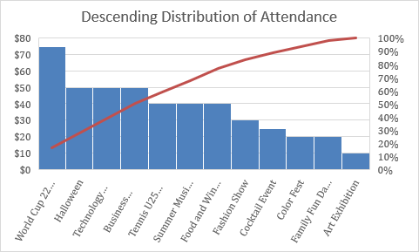

Figure 4 - Descending Distribution of Attendance

As observed in the above histogram, World Cup 22 dominated the distribution of attendance while Art Exhibition had the least distribution attendance.

## 4.3 System Analysis.

### 4.3.1 UML Diagrams:

Use Case Diagram: shows the interactions between actors (users, event organizers, administrators) and the system.

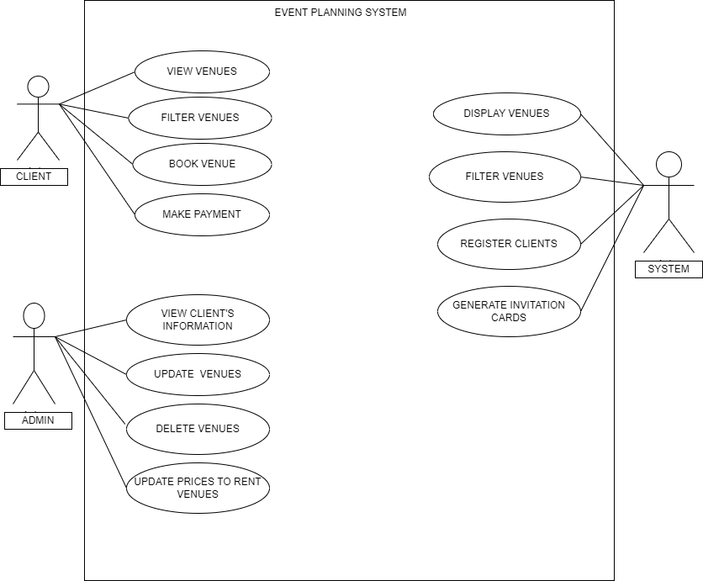

Figure 5 - Use Case Diagram

### 4.3.2 DFD:

Level 0 Diagram: shows the main processes in the system (event creation, event search, ticket purchase, event management, user management).

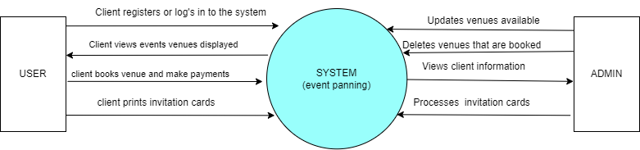

Figure 6 - DFD

### 4.3.3 Activity Diagram:

Shows the flow of events for specific user actions (event venue booking, renting the venue, generate invitation cards.)

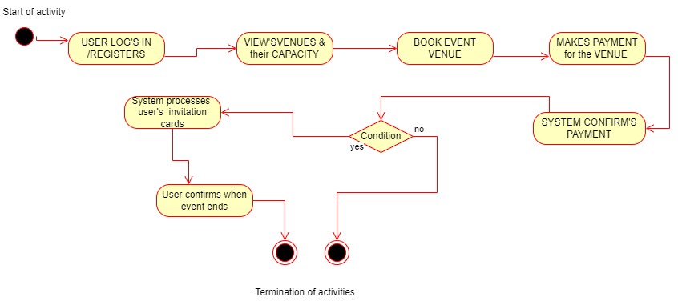

Figure 7 - Activity Diagram

## 4.4 System Design.

### 4.4.1 Flow Charts:

Show the step-by-step process for event creation, event search, ticket purchase, event management, and user management.

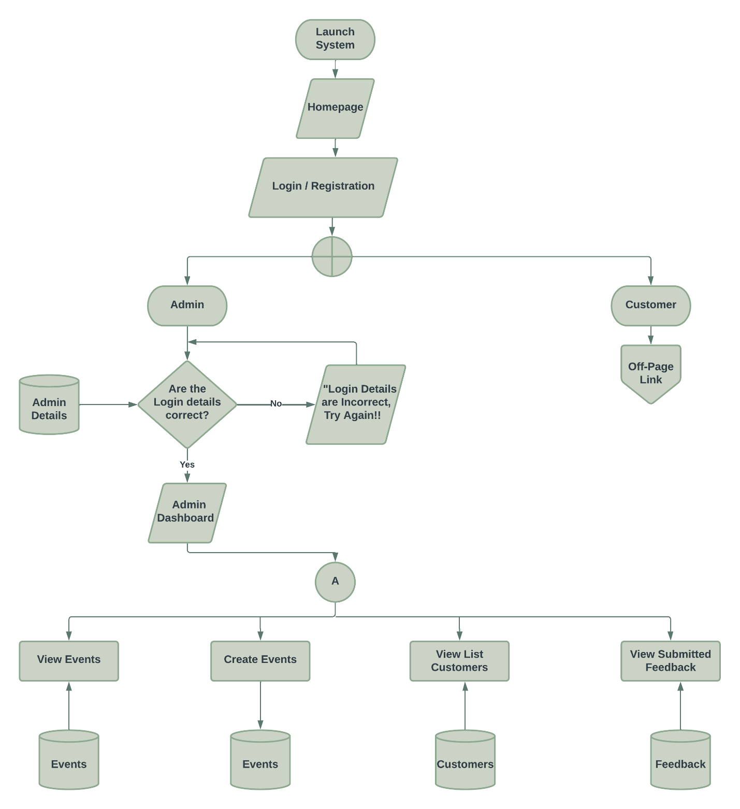

Figure 8 - Admin Flowchart

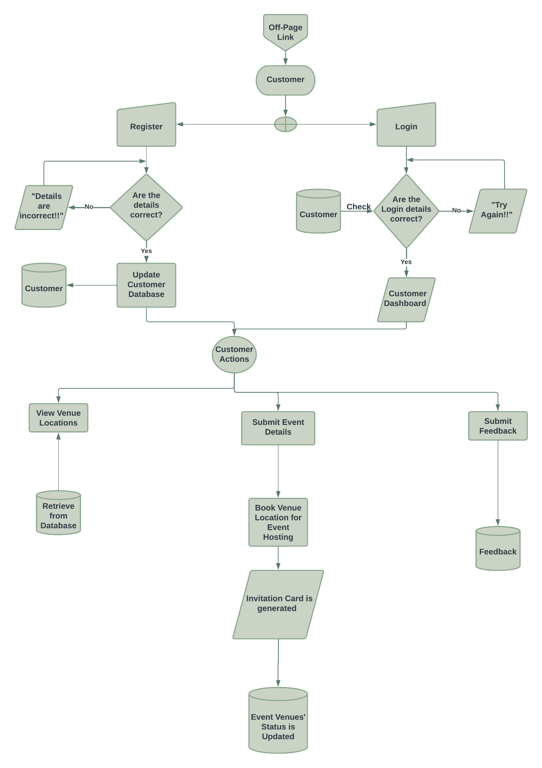

Figure 9 - Users Flowchart

The above flowchart gives an overview of how our Event Planning Management System will provide functionality to both the admin and the customers of the system. It will ease event planning, booking and management.

The users have various functions e.g., booking tickets, sending feedback, requesting account deletion and viewing available events in their dashboard.

### 4.4.2 UI Design:

Show the layout and design of the user interface for various pages (homepage, event listings page, bookings page).

Homepage UI:

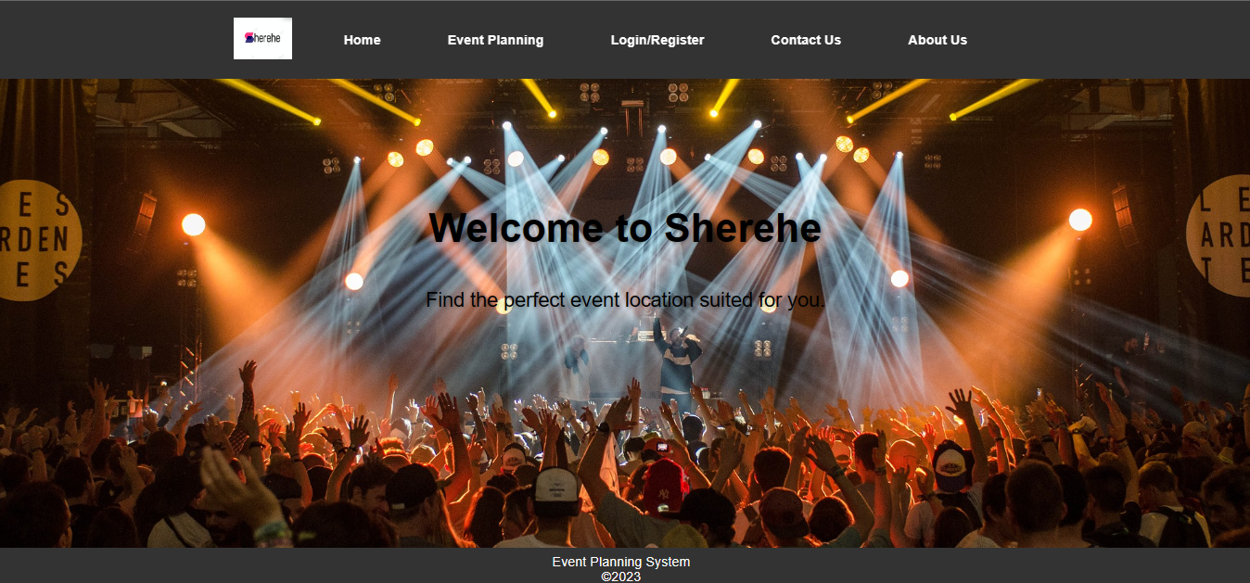

Figure 10 - Homepage UI

## 4.5 Database Design.

**Checkout Table Database Schema**

id (INT, primary key, auto-increment)

name (VARCHAR(30), not null)

phone (VARCHAR(15), not null)

email (VARCHAR(50), not null)

date (DATE, not null)

period (INT(2), not null)

events (VARCHAR(30), not null)

price (FLOAT, not null)

timestamp (TIMESTAMP, default current timestamp)



Figure 11 - Checkout Table Database Design

.

This schema enables the checkout table to store data about customer checkouts, including their contact information, the details of the event, and the total price of the checkout.

The nine columns used are for the following:

1. id is an unsigned integer with a maximum value of 6 digits, serves as the primary key, and auto-increments for each new row.
2. name, phone, and email are variable-length strings with maximum lengths of 30, 15, and 50 characters, respectively, and they cannot be null.
3. date is a date data type that cannot be null.
4. period is an integer with a maximum value of 2 digits that cannot be null.
5. events is a variable-length string with a maximum length of 30 characters that cannot be null.
6. price is a floating-point number that cannot be null.
7. timestamp is a timestamp data type that defaults to the current timestamp when a new row is inserted, and updates automatically when the row is modified.

# Chapter 5

## Test and Results.

### 5.1 Introduction

**Testing is** the process of evaluating and verifying an application or system software and its components to ensure it meets it’s specified requirements or not.

**Importance of testing**

* Enables one to identify errors, gaps or missing requirements
* Helps in preventing bugs in system
* Reduces the development costs
* Improves performance of the system
* Increases the acceptance of the project since as soon as the requirements are tested and met then the project is accepted

How testing is done?

**Stages of testing**

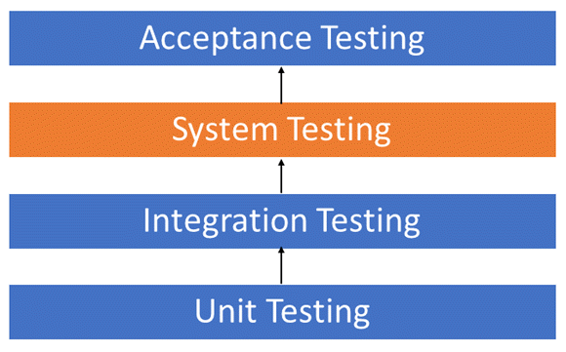

**Types of testing**

**Unit testing**

Unit testing is performed on individual code components or modules to ensure that each one is working properly

It is typically performed by developers that is the programmer who wrote the code

**Integration testing**

Involves testing how different code modules or components of a software system work together. A piece of software can contain several modules created by several programmers thus it’s crucial to test each module on the entire model before, during and after integration of new module into the main software.

It is performed to ensure that the overall system functions correctly and meets requirement

**System testing**

It is performed on the entire software system as a whole to ensure that t meets all requirements and function correctly. It’s done by professional testing agent on the completed system before its deployed in the market

**Acceptance testing**

It is performed to ensure that the software meets the business requirement s and satisfies the user’s needs. It is beta testing of the system ,which is done by the actual end users of that system or product owners.

***By performing these types of testing ,software developers and testers can ensure that the software system is functioning correctly ,meets the requirements and is of high quality.***

### 5.2 Test Cases.

**A test case -**It is a group of input values, execution preconditions, expected execution postconditions and results. A test case is executed using test data.

Test cases are essential part of software testing as they provide systematic way to verify the system requirements and functionality.

By creating and executing test cases, software testers can identify any defects or issues in the system and take the necessary steps to address them, ensuring the system is of high quality and meets the needs of its users.

#### 5.2.1 Test Case 1.

**Objective**: To check whether the admin or user can login or create account in the system and the output once a valid email for user and admin are input

**Test scenario:** Creation of an account and signing into the account

**Test data:**

Username1:briannte

Password: brid

Username2:briantte

Password:brid9

**Expected result** :user either logins successful or does not login due to incorrect credentials.

**Actual results:** The first test data the, user logged in successfully.

The second test data, user was not able to login due to incorrect credentials.

**Status: U**sing first test data-**pass**

Using second test data-**fail**

#### 5.2.2 Test Case 2.

**Objective:** It involves checking the venues if they are displayed and additional information of the venues.

**Test scenario**: Can the user view venues after logging in?

**Test data:**

Username1:briannte

Password: brid

**Expected result:** After the user has logged into his/her account ,he/she is able to view all the venues that are displayed in the dashboard

**Actual result:** Using the test data ,the user successfully views all the venues available in the system.

**Status:** Pass

#### 5.2.3 Test Case 3.

**Objective:** we test whether the user can book the venues through our online platform without errors

**Test scenario:** User chooses a venue for his event and books it.

**Test data:** Venue Bantu Africa resort,200 guests and price is 15000 shillings

**Steps:** The user clicks the book button in the Bantu resort Africa venue and is directed to the checkout page. Here ,user fills in the details of his/her event and the clicks book button that displays a confirmation message that booking is successful.

**Expected result:** The user is able to book venue of their choice

**Actual result**: User successfully books the venue and a confirmation message pops up

**Status:** Pass

#### 5.2.4 Test Case 4.

**Objective**: can the system generate invitation cards for the user to distribute to the attendees of his or her event after booking the venue

**Test scenario:** Generation of an invitation card

**Test data:** Venue Bantu Africa resort,200 guests and price is 15000 shillings

**Expected result:** The user can download the invitation card once he/she has booked the venue of their choice.

**Actual result**: User successfully generates the invitation card after booking by clicking the download invitation card button

**Status:** Pass

### 5.3 Sample Results.

This are the results of the test cases done previously.

#### 5.3.1 Sample Result 1.

This is the result we got after testing test case 1

**User**

The username is correct but password is incorrect thus a message pops about incorrect credentials hence user has to login again.

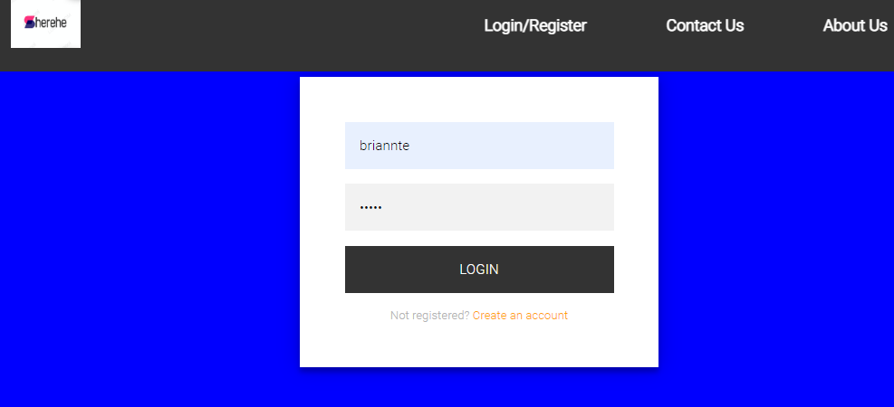 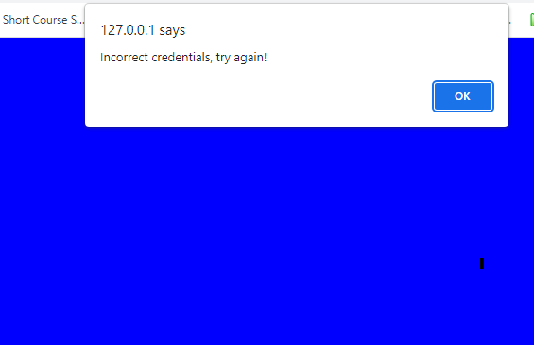

Once the user logs in with **username** briannte and **password** brid , he or she can see the venues available

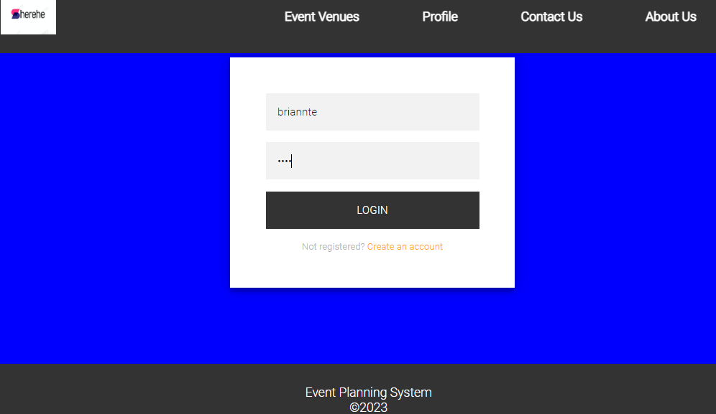 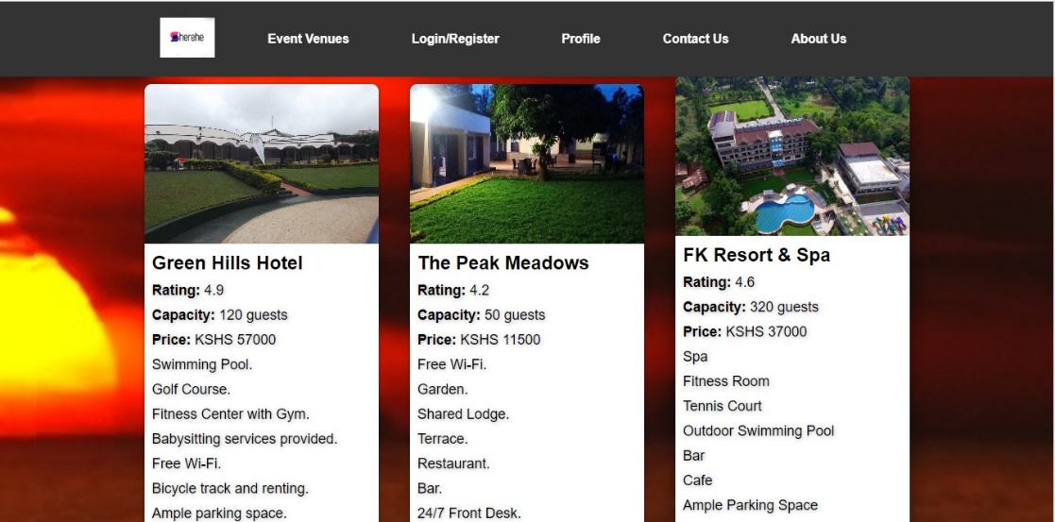

Figure 12 - Event Venues available

#### 5.3.2. Sample Result 2.

Once the user has logged in all venues are displayed for the user to view and choose.

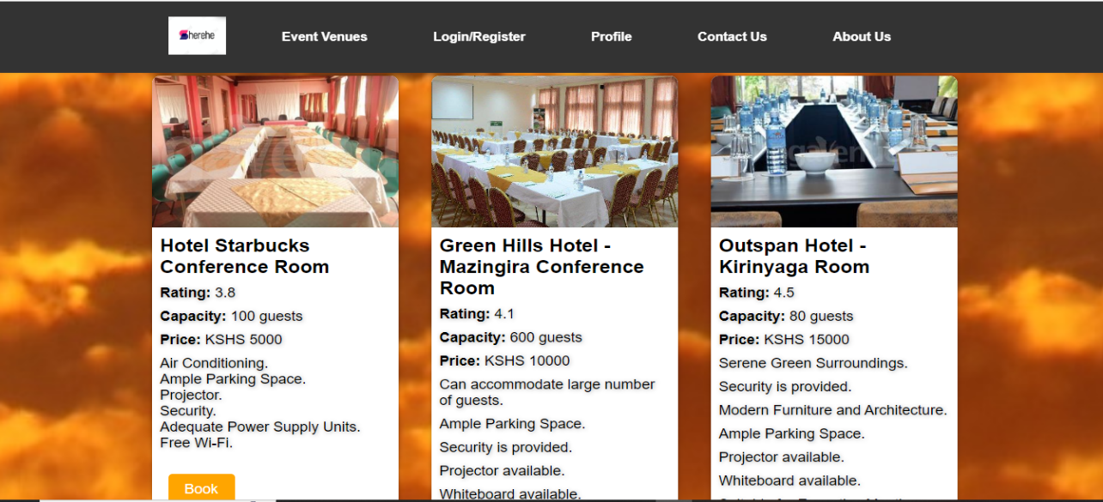

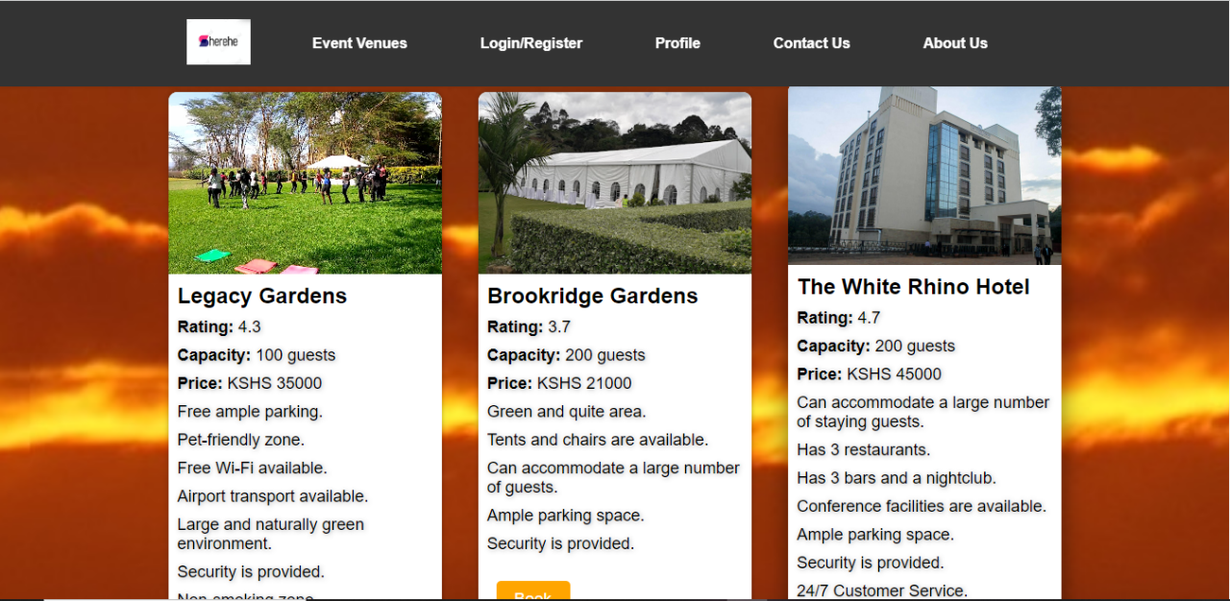

#### 5.3.3 Sample Result 3.

After viewing the venues, the user decides which venue is appropriate for his or her event and books the venue.

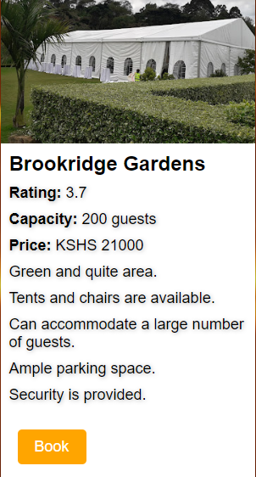 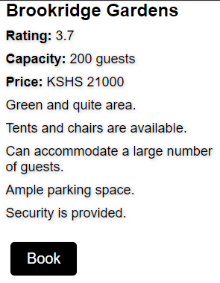

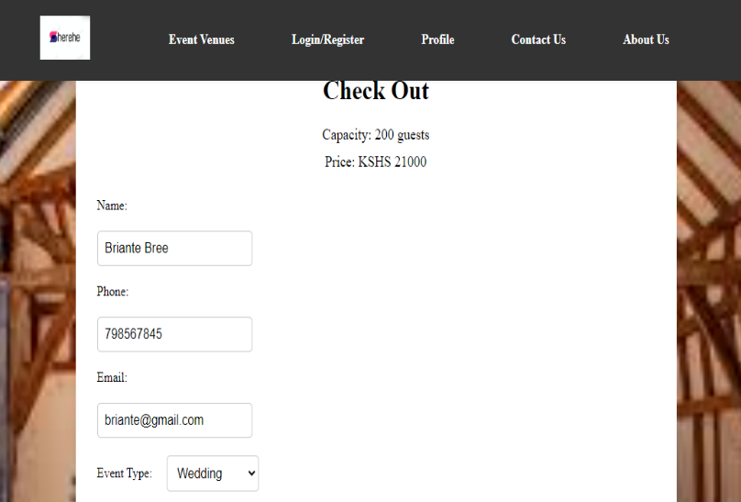 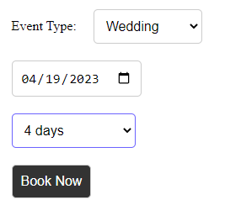

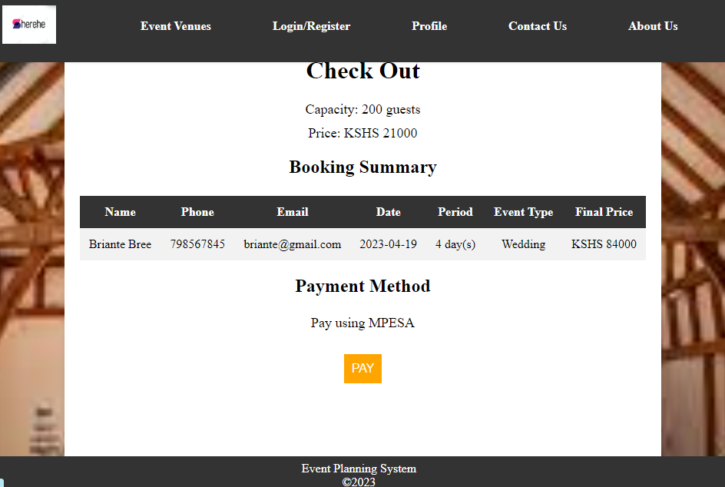

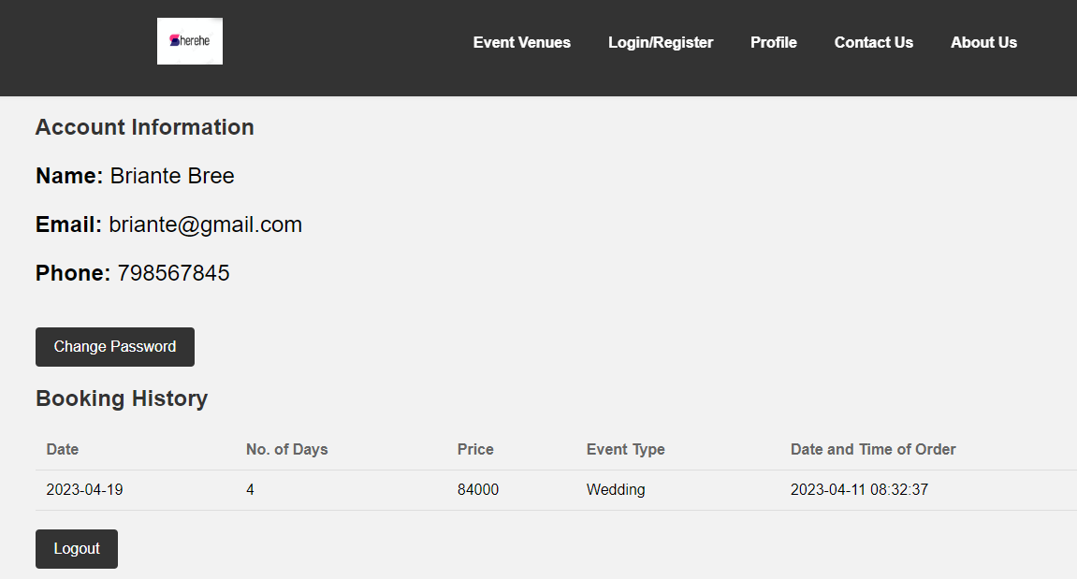

#### 5.3.4 Sample Result 4.

This is the result of test case 4 where user can generate an invitation card after booking the venue.

By pressing the download invitation card button ,the card is generated and the user saves it on his/her device.

He/she can print it or send to the attendees of the event electronically.

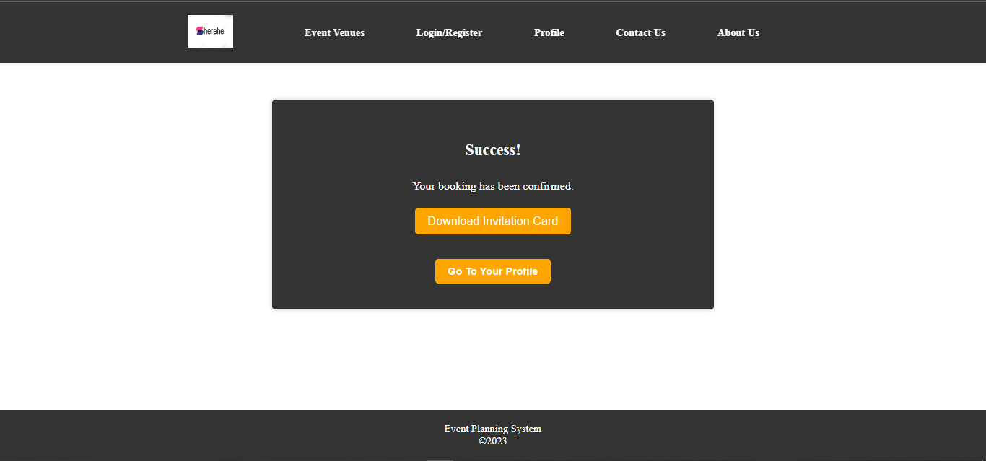

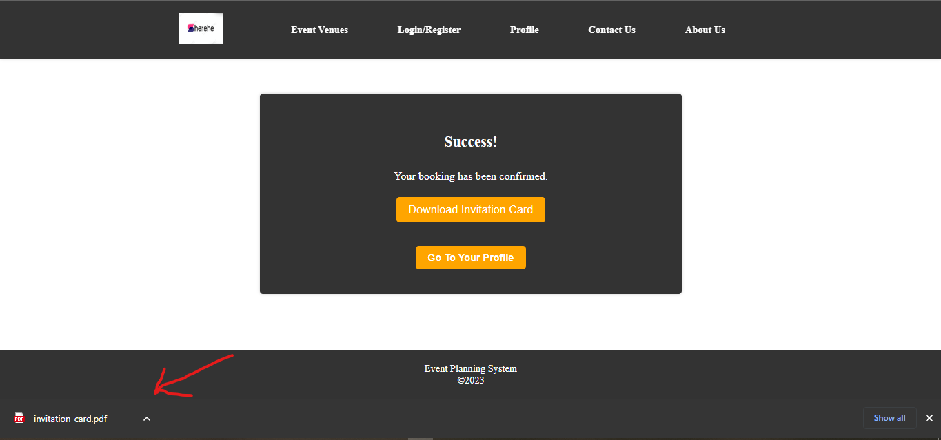

# Chapter 6.

## Implementation and Development.

### 6.1 Introduction.

**Implementation** is a process of ensuring that the information system is operational.

It involves :−

* Constructing a new system from scratch
* Constructing a new system from the existing one.

**System implementation is** a set of procedures performed to complete the design contained in the approved system design document and to test, install and begin to use the new or revised system.

**Objectives of system implementation**

* Determine, by thoroughly testing the system with users, that the system satisfies the users’ requirements.
* Ensure a correct conversion by planning, controlling, and conducting an orderly installation of the new system.
* Ensure that the client can operate the new system by training them and completing user manuals and documentation of the system.

### 6.2 Data Conversion.

It’s the process of translating data from one format to another.

It involves taking data from the old system, adding missing data to it and then transferring all the data to the new system.

**Conversion plan**-contains description of all activities that must occur during implementing a new system and put into operation. It anticipates possible problems and their solutions

It includes the following activities

* Name all files for conversions.
* Identifying the data requirements to develop new files during conversion.
* Listing all the new documents and procedures that are required.
* Identifying the controls to be used in each activity.
* Identifying the responsibility of person for each activity.
* Verifying conversion schedules.

**Points that ensures successful data conversion**

1. Analyze the scope of the project by being attentive to these three points:

* Analyze the **baseline data** considering their quality, quantity and integrity
* Assess **open transactional data** that is open accounting transactions
* Asses the **historical data** you wish to implement in the new system.

1. Apply a data conversion strategy that relies on the following :

* Prioritize tasks and actions to be completed
* Empower decision makers you encountered.
* Establish exactly who internally and externally will participate in the data conversion process
* Referring to the conversion plan, select the appropriate personnel
* Establish everyone’s level of participation including hours and exact timetable
* Develop a thoroughly detailed plan for the conversion of data while assigning tasks to all the stakeholders of the project

1. Define the mapping of your data as well as the standard sand rule applying to their conversion:

* Identify data sources including their origin.
* Examine and analyze data sources and compare them to target data
* Develop data loading/converting tool if possible
* Keep a copy of pre-conversion data sources.
* Document rules, templates and tools in detail

1. Test, validate and reconcile during the data conversion. This will make reconciling data source with target data easier.

### 6.3 Implementation Strategy.

There are several approaches used to implement a system

They include:

#### Direct Changeover.

The old system is stopped abruptly and the new system takes over with no validation if it’s comparable to the old system.

**Benefits**

It forces users to make the system to work

* Immediate benefit from new methods and controls

**Disadvantages**

* No fall back if problems arise
* Requires careful planning
* It’s the riskiest of all the strategies

I t’s sometimes called **Big Bang approach.**

#### Parallel Changeover.

Both the old and new system operate together simultaneously for a period of time until the user is confident to use the new system and reliable enough to fully replace the old system. There are fewer risks involved because everything is being worked on at the same time.

**Benefits**

* It require less management effort.
* More resources are easily available to develop the system.
* It guarantees that all subunits of the system will work on simultaneously.

**Disadvantages**

* More costly
* Time consuming compared to other changeovers

#### Phased Changeover.

It sometimes combines both direct and parallel approaches so as to implement the system.

The system is developed in phases that is one after another unlike in parallel approach where system runs in a parallel fashion. Thus each of the phases can be implemented independently as they are not dependent on each other

The new system is implemented into one subsystem at a time or introduced in phases as an organizational unit.

**Benefits**

* System schedules and budgets can be managed accurately due to the dependencies between phases being clearly defined.
* There is less risk involved because each phase will begin only after all of its prerequisites have been completed successfully.
* Preferred when new system involves new technology or drastic changes in performance.
* Provides experience and line test before implementation

**Disadvantages**

* Provides experience and line test before implementation

We will use phased implementation strategy because our system will need to be developed and updated in phases. We will implement our system based on the users feedback .Our old system only displayed venues and clients booked venues manually. This new system provides an online platform for users to book venues .This makes phased strategy suitable as we will implement our system in phases thus improving it.

### 6.4 System Specification.

It is a detailed description of the software, hardware and other components that make up a computer system. It describes the operational and performance requirements of a system **example** computer.

It is a document that outlines the requirements for a system and it is used by designers, developers and engineers to ensure that the system meets the need of its users

System specification outlines how the system is expected to perform and may determine the security access to the system.

There are two main types of system specification:

1. **Technical specification**-it describes the technical aspects of a system. It outlines the hardware ,software and networking requirements of a system
2. **Functional specification**-it defines the functions of the system in terms of what it must do. This includes its features, functions and capabilities .it specifies the inputs, outputs and processes of the system and provides a clear understanding of how the system will behave in different situations.

#### 6.4.1 Technical Specifications.

##### 6.4.1.1 Hardware Specifications.

These are the hardware components that will be needed to develop a system.

We will require several hardware components to aid in developing our system.

**They include:**

1. Laptop or desktop computer
2. Compatible disk drives
3. Mobile phones
4. 8GB Ram for 64 bits
5. 4GHZ Processor Intel core i5
6. USB,HDMI
7. Ethernet ports
8. 16terabytes hard disk or 2terabytes solid state disk

##### 6.4.1.2 Software Specifications.

These are the software or applications that will aid in developing a system.

**In our system we will use:**

1. Visual Studio code and Sublime text for coding.
2. Xampp for providing the interface to run MySQL and Apache servers.
3. PhpMyAdmin for local hosting in MySQL.
4. Operating system can be windows 10,linux,ubuntu,macos or parrot
5. Drivers
6. Firmware

##### 6.4.1.3 Networking Specifications.

We will need network for research as we develop our system.

1. Ethernet
2. Wi-fi
3. Modem
4. Bluetooth

#### 6.4.2 Functional specifications

It defines what the system must do to meet users’ needs.

##### 6.4.2.1 User Requirements.

It specifies the needs and expectations of the system users. They include:

1. Create an account if user does not have one
2. Sign in to his/her account
3. View venues displayed in the system
4. Book venue of their choice
5. System can generate an invitation card for the user

##### 6.4.2.2 Functional Specifications.

Features and functions the system has to perform. They include:

1. Data entry-System provides a form that a user can enter his/her details pertaining the venue or creating account
2. Data storage-system can store the data entered by user in its database
3. Retrieval of data-system allows retrieval of the data that it stored in its database .For instance when user is signing in to his account after creating the account.

##### 6.4.2.3 Security Requirements.

It specifies the security measures that the system must have to protect sensitive data of its customers.

1. Authentication-before the system can view venues available , he/she has to verify their identity by logging into the system
2. Encryption-the system encrypts data to avoid unauthorized access to sensitive data
3. Access control determines which resources the users can access.
4. Backups-the system backups its data in case of loss of the original data.

### 6.5 Support and Training.

Once we have deployed our software and a client installs it, he /she will need to familiarize with the software. As developers of the system we will need to conduct some training to aid the users navigate the software. This training will help users know what their roles will be, how they can use the system and what the system will do and not do. The training will be conducted for at least two weeks. The success or failure of a well-designed system can depend on the way it is operated and used thus training the users is paramount.

Training involves familiarization with run procedures, which involves working through the sequence of activities needed to use a new system. We will user the instructor-led training method to train users so as to complete the training faster. This method involves both trainees and trainers, who have to meet at the same time and place.

# Chapter 7.

## Conclusion and Recommendations.

### 7.1 Conclusion.

Event planning is a complex process that requires a comprehensive understanding of various factors such as client needs, location, and budget. To create a successful event planning system, it is important to conduct a thorough literature review to identify the best practices in the industry. This should be followed by the development of a methodology that encompasses research design techniques, sampling procedures, data collection tools, and data analysis techniques. In this study, we have chosen Kenya as our location of study and we will be focusing on the population of event planners in the country specifically those around Nyeri. The data collection tools that we will be using include surveys and interviews. We will also test the reliability of the data collection tools to ensure the accuracy of the data. Finally, we will adhere to research ethics in our study by ensuring confidentiality, obtaining informed consent, and protecting the rights of the participants. The insights generated from this study will contribute to the development of an effective event planning system that can be applied not only in Nyeri but can also be integrated in other parts of the country as well as worldwide if successful.

### Appendices.

#### Sample Questionnaire.

We have decided to carry out a questionnaire so as to get opinions/feedback from our intended system users. By using questionnaires, we feel that we will get genuine opinions about our system which will help us to improve it by adding or removing certain features.

The questionnaire is a google form

<https://forms.gle/KiEYMRUny14dvvna9>

#### Budget of our System.

It’s inevitable to use a certain amount of money to develop our system. Apart from development costs, we will incur some expenses to keep our system functioning. These expenses are the operational costs. We will set approximately 300,000 Kenyan shillings for both development and operational costs. However, three quarter of the money will be restricted only for development of the system.

#### Time Schedule.

|  |  |  |
| --- | --- | --- |
|  |  |  |
| Day 1 | W**e** discussed the preliminaries |  |
| DAY 2 | We discussed chapter 1: **Introduction** |  |
| Day 3 | We discussed chapter 2: **Literature review** |  |
| Day 4 | We discussed chapter 3: **Research methodology** |  |
| day 5 | Then finally we discussed chapter4: **System design** |  |

#### References

Allen, J., Harris, R., Jago, L., Tantrai, A., Jonson, P., & D'Arcy, E. (2022). Festival and special event management. John Wiley & Sons.

Carter, L., 2007. Event planning. AuthorHouse.

Dowson, R., Albert, B., & Lomax, D. (2022). Event planning and management: Principles, planning and practice. Kogan Page Publishers.

Kilkenny, S., 2011. The complete guide to successful event planning. Atlantic Publishing Company.